**User Guide**

**Scheduling sessions:**

1. To start scheduling, press the “Schedule sessions” button in the main page:Graphical user interface, application

   Description automatically generated
2. In the following page, select a semester, class, course, date for the session, starting time, number of lessons, how weeks ahead it should repeat (same day of the week at the same time), and a classroom for that session. If anything is missing, an error label will appear.

1. If all the fields are filled out but the session overlaps with other sessions, it will show an error label and the session will not be scheduled:

1. If everything is done correctly, after pressing the “Schedule” button, the session should be scheduled, and no errors should appear:Graphical user interface, application

   Description automatically generated

Rescheduling or Cancelling Sessions:

1. To see all the sessions for a specific class and week, press the “Reschedule or cancel sessions” button in the main page:Graphical user interface, text, application

   Description automatically generated
2. In the following window, it is possible to search for sessions by class and week. There are two options when a session is selected: to cancel or reschedule it.Table

   Description automatically generated with medium confidence
3. To cancel a session, select one of the sessions and then press “Cancel session” button. The session will then be cancelled and removed from the table.
4. To Reschedule a session, select it, and then press the “Reschedule selected session” button. This window should appear:Graphical user interface, application

   Description automatically generated
5. It will show what session is being rescheduled. Then by selecting a date, start time, number of lessons and a classroom, if the date does not overlap with any other sessions, by pressing “Reschedule button” the session should be rescheduled:

**Managing students and changing their class:**

1. To see all the students, press the “Manage students” button on the main page: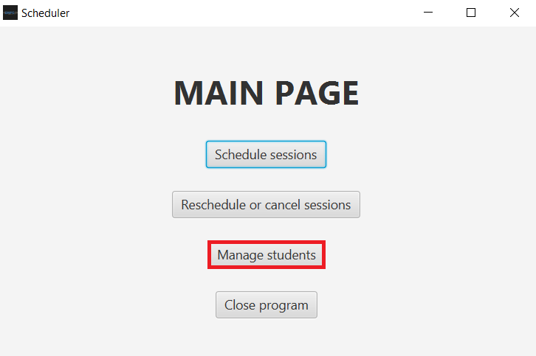
2. Then, all the students will be displayed in the page. It is possible to search for them by Name, Class or Via ID.

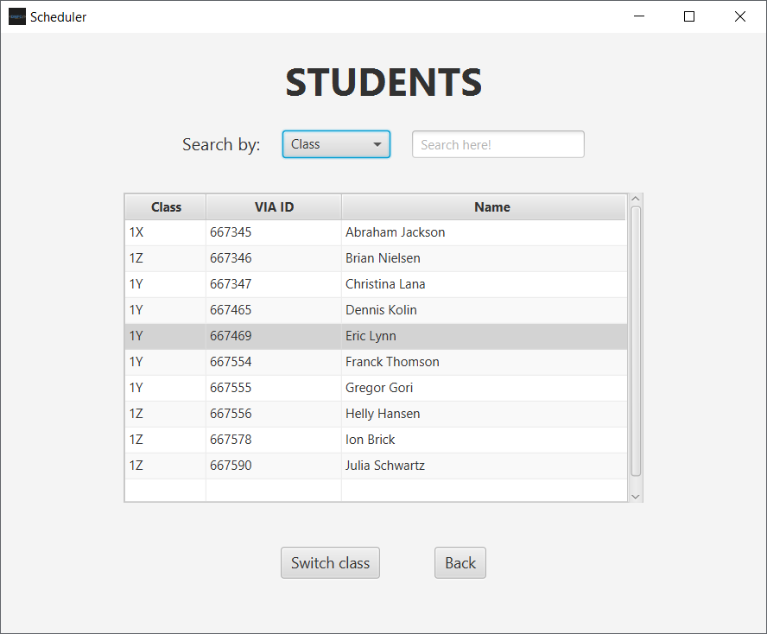

1. To change their class, select a student by clicking on them and pressing the “Switch class” button.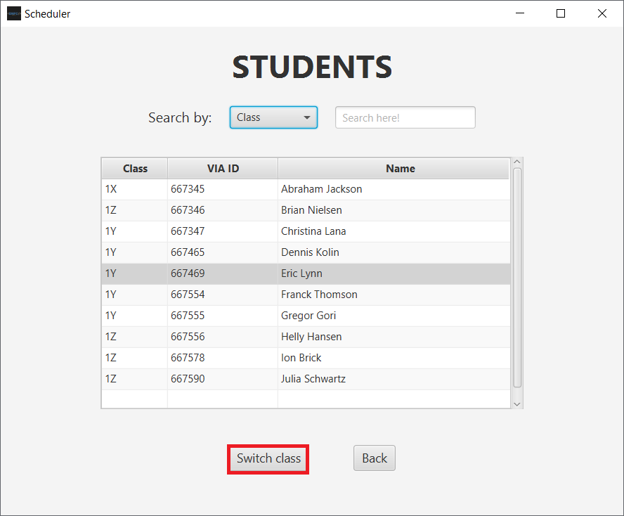
2. Then, the pop up will appear that will allow to change the student’s class:

